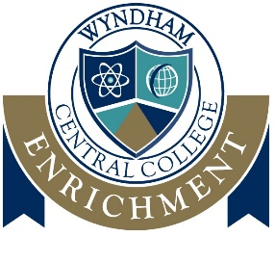
Wyndham Central College
Year 7 Enrichment Program 2020

Dear Parents /Guardians
We warmly welcome your child to Wyndham Central College as our future Year 7 student for 2020. The transition from primary school to secondary college is a very exciting time. This letter is to inform you that your child has the opportunity to apply for our Enrichment Program.
The Enrichment Program at Wyndham Central College will provide students, who have been identified as having a particular gift and/or talent, with a developmentally appropriate program. The program allows students access to learning opportunities that challenge and extend learning in a chosen subject area. Enrichment experiences will be interwoven into tutor time and the normal class timetable, with extra-curricular activities playing an important role in supporting the enrichment project.
Selection into the Enrichment Class
The selection process will be informed by:
- Student’s most recent school report
- Year 5 NAPLAN test results
- Student’s Personal Statement
If you and your child wish to express interest in the Enrichment Program, you are required to complete the attached application. The application is to be completed by both parent/guardian and student and returned to Wyndham Central College’s administration office by:
Friday 11th October 2019
Once applications have been received, the Enrichment Panel will meet to discuss each student’s suitability for the Enrichment Program. All students and parents/guardians will be notified as to the outcome of their application by letter.
For further enquiries, parents are welcome to contact Sue Butcher (Enrichment Coordinator) or Megan Taylor (Assistant Principal). Further details about the Wyndham Central College Enrichment Program can be found on the College website.
Kind Regards

Ms Sue Butcher Ms Leanne Gagatsis
Enrichment Coordinator Principal

