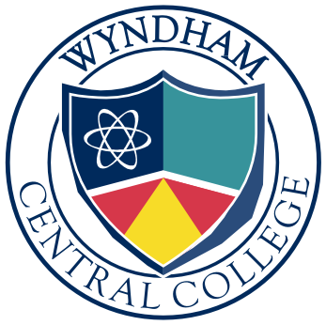
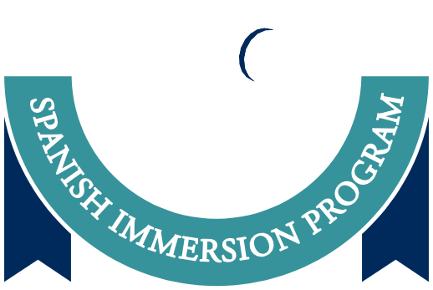

WYNDHAM CENTRAL COLLEGE
SPANISH IMMERSION PROGRAM

Application Form 2020

Date:

Student Name:

Primary School currently enrolled at: Parent Name:
Email:

Home Phone number: Mobile:
Home / Postal Address:

Parent/Guardian Signature:

