school Smoking and Vaping Ban
By law, smoking and vaping are banned within the grounds of, and within four metres of an entrance to, all childcare centres, kindergartens, preschools and schools.

Where the ban applies
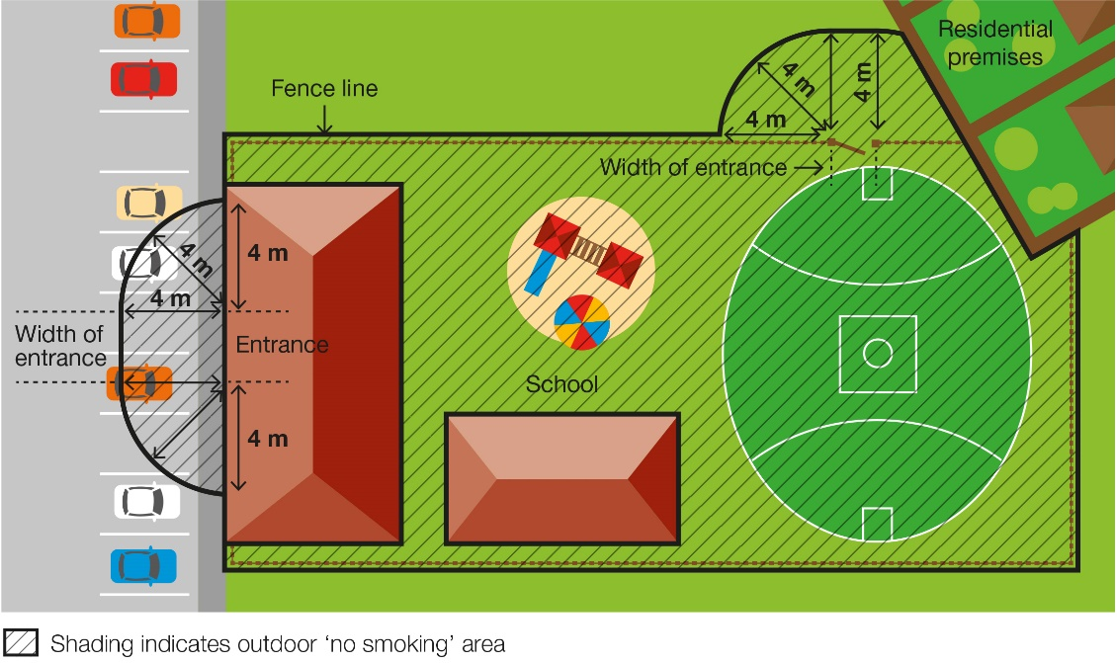
The smoking and vaping ban applies to:
- anyone present on school premises during and outside of school hours including students, teachers, contractors, parents or carers or the wider community, such as sporting groups
- all activities that take place on school premises including pre-schools, kindergartens, outside school hours care, cultural, sporting or recreational activities and school fetes
Smoking and vaping are also banned within four metres of any part of a pedestrian access point (entrance) to the premises.
The diagram adjacent shows an example of where the smoking ban applies at a school.

When the ban applies
The smoking and vaping ban applies at all times, no matter whether the building or school grounds are being used for education purposes or other purposes. The ban therefore applies when other activities are taking place on the school grounds, such as fetes or sporting events, as well as during school hours.

Why the ban exists

To protect children and young people from the dangers of second-hand smoke and vapour
This ban ensures that children and young people can enter and leave these areas without being exposed to harmful second-hand smoke and vapour. Their health is particularly at risk because they have smaller airways and less developed immune systems compared to adults.
To reduce the role modelling of smoking and vaping behaviours around children and young people
Children and young people are more likely to view smoking and vaping as socially acceptable when they regularly see people doing it.
Banning smoking and vaping in areas used by children and young people will discourage children and young people from using tobacco or e-cigarette products.

Defining a pedestrian access point

A pedestrian access point in relation to premises means a door or gate by which a person can enter or exit the premises. It does not include an emergency exit that is locked to entry.
It does include shared doors or gates. For example, where a building is occupied by a childcare centre as well as other organisations, such as private businesses, any shared entrances that are used to access both areas of the building would be subject to the smoking ban.
Any entrances which lead only to premises not included in the smoking ban, such as the private offices, would not be subject to the smoking ban.

What penalties apply
Fines are described under law in penalty units. From 1 July 2020 to 30 June 2021, a penalty unit is valued at $165.22.
The penalty for breaking school smoking and vaping ban laws is a court fine of a maximum of five penalty units ($826 as of 1 July 2020) or an infringement fine of one penalty unit ($165 as of 1 July 2020).
The value of a penalty unit is set annually by the Department of Treasury and Finance and is updated on 1 July each year. For current penalty unit values, visit the Department’s website <www.dtf.vic.gov.au/financial-management-government/indexation-fees-and-penalties>.

For more information
For more information:
- visit the tobacco reforms website <www.health.vic.gov.au/tobaccoreforms>
- call the Tobacco Information Line on 1300 136 775
To view the legislation visit the Victorian Government’s legislation website <www.legislation.vic.gov.au> and search Tobacco Act 1987.

© State of Victoria (Department of Education and Training) 2020. Except where otherwise noted, material in this document is provided under a
Creative Commons Attribution 4.0 International Please check the full copyright notice

